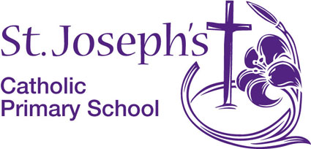Woodford Lane

Winsford

Cheshire

CW7 2JS

The Governors seek to appoint a **Temporary Main Pay Scale (M1 to M5) Class Teacher for Maternity Cover** from 5th May 2025 for up to 12 months

St. Joseph's is a thriving Catholic Community. We have happy children and a dedicated, friendly and supportive staff team. St. Joseph’s is a good school which offers an outstanding Catholic education for its pupils (Diocesan Inspection November 2016).

We are looking for a teacher who has high expectations and who has the gift of inspiring children in their learning. Candidates must be innovative and creative with the skills to plan, deliver, evaluate and asses a rich and varied curriculum which allows every child to fulfil their potential. We are seeking a teacher who is able to demonstrate a clear understanding of what constitutes outstanding teaching and learning along with the drive to maintain exemplary standards and progress. This position is not suitable for an ECT. As a Catholic school, a commitment to our school values is essential.

The school is committed to safeguarding and promoting the welfare and safety of children. The successful candidates will be required to complete an enhanced DBS disclosure and will follow a stringent vetting and induction process.

Prospective candidates are warmly welcomed to visit the school, please contact school to make an appointment.

Closing date: Friday 7th March 2025 12pm noon

Interviews: TBC Week beginning 10th March 2025

Please note that applications **must** be submitted on the most up to date CES application form and returned to [sbm@stjosephs.cheshire.sch.uk](mailto:sbm@stjosephs.cheshire.sch.uk). Further information is available from our website www.stjosephs.cheshire.sch.uk.