**1600**

**1700**

**1800**

**1900**

**2000**

**Ibn Battuta 1304–1369**

**Living memory**

**1500**

**1400**

**1300**

**Captain James Cook 1728–1779**

**Captain Robert Scott 1868–1912**

**Roald Amundsen 1872–1928**

**Sunita Williams 1965–present**

**Important things to know**

1. **Explorers** travel to new places for different reasons. These include to discover new things, for fame, to help others and to find a fortune.
2. Ibn Battuta travelled for 30 years. He went further than anyone else at that time, for example to central and south-east Asia.
3. Some people think Captain Cook is a great explorer and that he ‘discovered’ Australia and New Zealand. However, he brought suffering to **indigenous** peoples. Many people do not agree he is a great explorer.
4. Roald Amundsen reached the South Pole before Captain Robert Scott in 1911.
5. Captain Scott is considered a **hero**, although he and some of his men died on the expedition to the South Pole.
6. Sunita Williams is an American astronaut who was given many awards for her achievements.
7. There have been many more male than female explorers.
8. These explorers are considered to be so **significant** that their achievements are remembered with **memorials** including statues, stamps, coins and street and place names.
9. Written records like Scott’s diary are an important way of finding out about explorers. We can also use photographs, maps and objects.

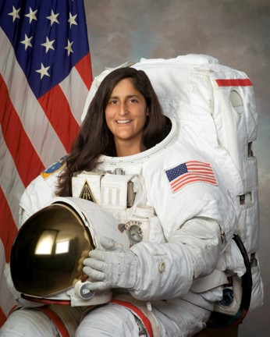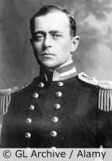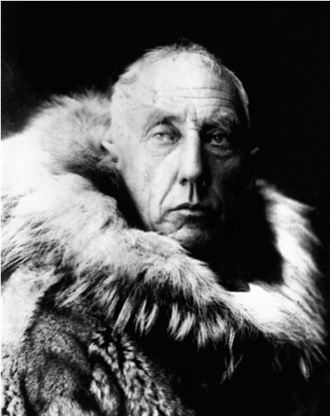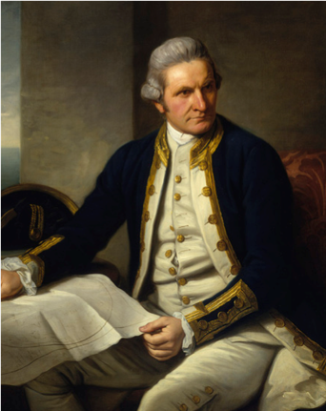

**5 words to remember**

**explorer**

**hero**

**indigenous**

**memorial**

**significant**

**The greatest explorer is…**

**because…**

**Sunita Williams**

**Roald Amundsen**

**Captain Robert Scott**

**Captain James Cook**

**Ibn Battuta**